***Solar system crystal ball***

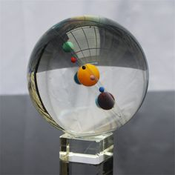

*The solar system crystal ball is dense, very firm in the hand. The black crystal base keeps the ball steady. The base and sphere are separate. We have fastening support if you want. This product is very suitable as a birthday gift for a boyfriend, a gift for a boss, a gift for teachers or colleagues in the company,*